Glossary I
Return to main Glossary index

ICs
Integrated Circuits are usually called ICs or chips. They are complex circuits which have been etched onto tiny chips of semiconductor (silicon). The chip is packaged in a plastic holder with pins spaced on a 0.1“(2.54mm) grid which will fit the holes on stripboard and breadboards. Very fine wires inside the package link the chip to the pins.
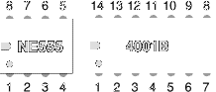
http://www.kpsec.freeuk.com/components/ic.htm

ICSP
In Circuit Serial Programming.
A means whereby PICs and other microprocessors, may be programmed while mounted in the circuit they are intended to control. Most, if not all, CBus modules are provided with a connector to facilitate this. A lead to connect the popular PICKit programmers to the CBus connector is shown here.

Incandescent lamps
Lamps emit light when an electric current passes through them. All of the lamps shown on this page have a thin wire filament which becomes very hot and glows brightly when a current passes through it. The filament is made from a metal with a high melting point such as tungsten and it is usually wound into a small coil.
Filament lamps have a shorter lifetime than most electronic components because eventually the filament 'blows' (melts) at a weak point.
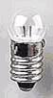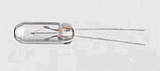
http://www.kpsec.freeuk.com/components/lamp.htm

Inductor
An inductor is a coil of wire which may have a core of air, iron or ferrite (a brittle material made from(iron). Its electrical property is called inductance and the unit for this is the henry, symbol H. 1H is very large so mH and uH are used, 1000uH and 1000mH=1H. Iron and ferrite cores increase the induction.
Inductors are mainly used to tune circuits and to block high frequency AC signals (they re sometimes called chokes)
They pass DC easily, but block AC signals ,This is the opposite to capacitor.
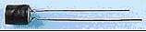
http://www.kpsec.freeuk.com/components/other.htm#inductor

Infra red emitter
These IR emitters are high intensity Gallium Arsenide infrared emitting diodes mounted in clear plastic with a smoke color lens. They are made with Gallium Aluminum Arsenide window layer on Gallium Arsenide Infrared emitting diodes. Viewing angle is 20 degrees
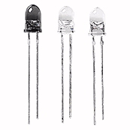

Infra red receiver/detector
Two types of IR receivers are used, a phototransistor or a photodiode
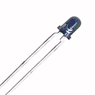

Insulfrog
Description used by UK track manufacturer, PECO, to denote turnouts manufactured with an insulated crossing (frog). This avoids the need for polarity switching for the crossing at the expense of poorer current collection for locomotives.

Interlocking
Name for means of linking the operation of points and signals such that signals can only show a proceed aspect when points are correctly set, and that points cannot be moved unless the signals over them are showing stop aspects. Interlocking can be mechanical, electrical using relays or carried out by computers.

