Replace Somewhere with the name of your area group.

MERG Scottish Borders Area Group
MERG Home page | Area Groups | More on our Knowledgebase | Group Members Page

Replace photo with a area group meeting photo
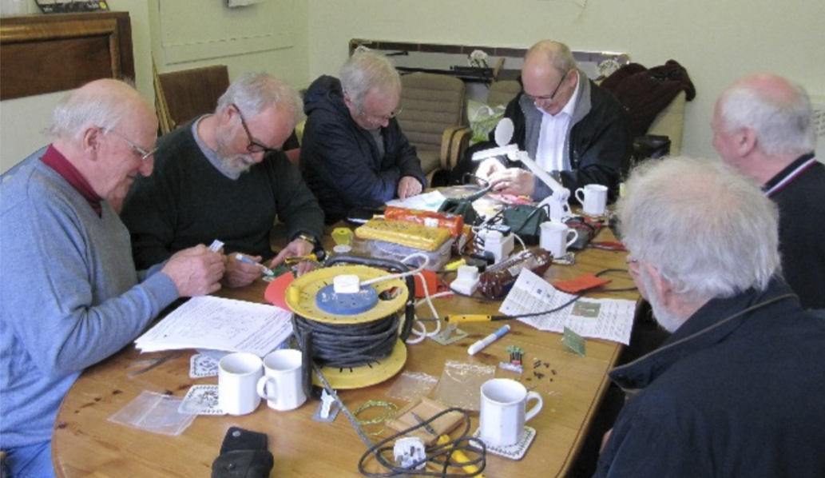

How do I contact the Area Group
* Replace NN with the number of your area group - get from the AG admin page. Update the contact form title. *
Please indicate Scottish Borders Area Group in your message Contact MERG

Who are the leaders of the group?
Replace photo with the names and titles of leaders.
Keith Torrington M5366 - Leader
Jim McPherson M7082 - Deputy
Martin Pearson M6513 - Deputy
Andy Robb M4360 - Deputy

Would you like to join today?
Update area group name.
Not a member? then
Join MERG Here
and sign up to this Area Group. If you are already a member
Join the Scottish Borders Area Group
Select Scottish Borders Area Group from the drop down list in Other Area Groups and press the Subscribe to Area Group button.

How do you meet?
Provide meeting details
We are now having one zoom meeting and a fortnight later a face to face meeting, ( There is no charge for the zoom meetings)
We met at Hawick Men's Shed, 7 Lothian Street, Hawick TD9 9HD.
A contribution of £3.00 is made per person per meeting at the Shed
A blog site shared with the Cumbria Area Group has been set up for informal communication during these current Covid-19 restrictions
It can be accessed here Cumbria and Sottish Borders Blogspot

And the Next Meeting?

Local Links
Link to local model railway sites.
Hawick and District Railway Society
Why not try out our blog for the Scottish Borders and Cumbria
MERG Home page | Area Groups | More on our Knowledgebase | Group Members Page

