MERG 3D SIG (Special Interest Group)
A zoom meeting group only
MERG Home page | Special Interest Groups

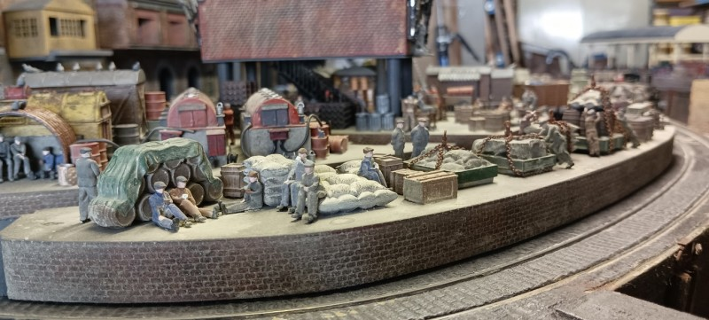
Picture Of Essex Brick By Eddy M3003

What are the Aims of the SIG?
The MERG 3d SIG covers many aspects of 3d modelling and some 2d modelling and aims to help and encourage interested members in a friendly atmosphere.
The meetings are designed to give advice and help to those experienced and to those just starting out in the world of 3d modelling. Demonstrations are given by experienced 3d modelling members and cover all aspects of 3d modelling.
We are a very active group with many members showing there printed designs. Members use many machines to achieve there 3d modelling. FDM(filament) and MSLA(resin) printers seem to be the most popular at the moment and members achieve some fantastic models. 3d modelling software is also covered, with demonstrations held regularly covering many popular software packages. Demonstrations cover things like, the use of various CAD and Slicer(programs to control 3d printers) software. We are always open to suggestions for certain techniques or software to be shown at our meetings.
We also have a large archive of previous meetings on the SIG TV Channel which are available to MERG members.
Contact the Group leader if you would like to come along and say Hi at one of our meetings.

How do I contact the 3D Modelling SIG?
Please indicate 3D Modelling SIG in your message
Contact MERG

Who are the leaders of the group?
John Holmes

Would you like to join today?
If not a MERG member then
Join MERG Here
and sign up to this Special Interest Group.
If you are already a MERG member then
Join the 3dsig
Select 3dSig from the drop down list in Other SIGs and press the Subscribe to SIG button.

How do you meet?
The group meets online using Zoom roughly every 2 weeks and members join the meeting from around the globe.

And the Next Meeting?
Best viewed in landscape on a phone.

How do Video Calls Work?
To join in you may need to add a headset with microphone and optionally a camera to your device, if they are not built in. You will receive a link which will get you into the meeting, automatically installing Zoom on your device if necessary.
Calls are scheduled and topics announced in advance.
Zoom provides thumbnails of each video participant and any shared presentations or desktops. The call host facilitates the meeting/questions/discussion. Zoom has developed a lot during Covid and I can't describe all the features here.
Usually everyone mutes their microphone to avoid a lot of noise from phones, clocks chiming, family activity etc. To speak you can just press the spacebar to (after a slight pause) temporarily unmute.
You can select among several icons to, for example raise a hand, clap, agree, vote etc. Useful for questioning.
You can also type “chat” either with everyone or with a selected participant. This is quite a good way to have a one-to-one conversation without involving/annoying everyone else. It can also be used to distribute weblinks etc although there are many other ways to “share” (with permission) screens, documents, open apps, whiteboard and so on.
If you would like to try out Zoom, then there is a test meeting service where you are the only participant and you can experiment with the various options available.
Test Zoom
This link is available to anybody, not just members.

3D SIG Member Page

