Shuttle Demo - ATC & CSR4
The ATC & CSR4 kits shown here have been discontinued and replaced by ATC2 & ENDS, functionality remains the same, the PCBs have been redesigned to provide greater flexibility in implementing more complex setups.
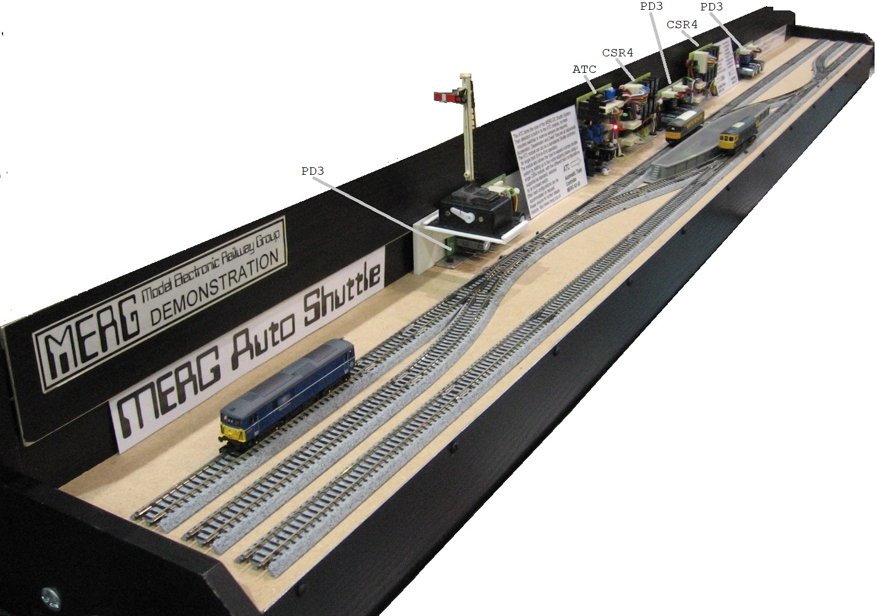
The shuttle module or ATC (Automatic Train Controller) MERG Kit 46, comes preprogrammed with a number of different configurations, selectable using an on board 4 way DIL switch. The track on this demonstration board is a symetrical arrangement that allows all of these configurations and the module cycles through these.
The track is Kato Unitrack, the points have integral motors using a two wire arrangement where the direction of current flow determines direction in which the points are set. The points here are driven by PD3s, MERG Kits 37a & 37b.

Configurations for the ATC
- A: End to end, plain track with stopping place at each end.
- B: 2 ends to 1 end, 2 stopping places at one end, with a single stopping place at the other.
- C: 2 ends to 2 ends, 2 stopping places at each end with plain track between.
- D: 3 ends to 1 end, 3 stopping places, hidden sidings maybe, at one end and a single stopping place the other.
- E: End to end with passing loop, stopping place at each end, with 2 further stopping places in the loops, island platform maybe.

Wiring arrangements
The ATC module has two track outputs designated 'End' and 'Intermediate'. For a simple end to end no other modules are needed, the two end sections are isolated in both rails and the 'End' output connected to these, the 'Intermediate' output is connected to the remainder of the track, observing correct polarity throughout.
For any configuration with more than 2 ends, some switching is required, this is achieved using the CSR4 (Cab Select Relay x 4) module, MERG Kit 46. This has 8 relays arranged in pairs providing a means of switching either of the ATC outputs or none (off) to each of 4 supplementary outputs. This gives provision for 4 stopping places or ends which may be at any one time off, end or intermediate.
In the photo the demo is currently on Configuration 'E', the move just completed is the loco at the front platform from the far end front. Next move will be the loco at rear platform to far end front, next after that will be loco at near end rear to rear platform, then loco at front platform to near end rear.

